1：

It would be very tempting to list the issues and problems of sustainable development and the future of sustainable development at length, but there is just such a list in the report and in the resolution proposed by the Committee on the Environment, Public Health and Consumer Policy. So I shall refrain from doing so. I mainly want to explain the logic behind the political message we want to send out. So let us begin with the bottom line and the bottom line, ladies and gentlemen, 10 years after Rio, is clearly in the red. With the exception of Kyoto

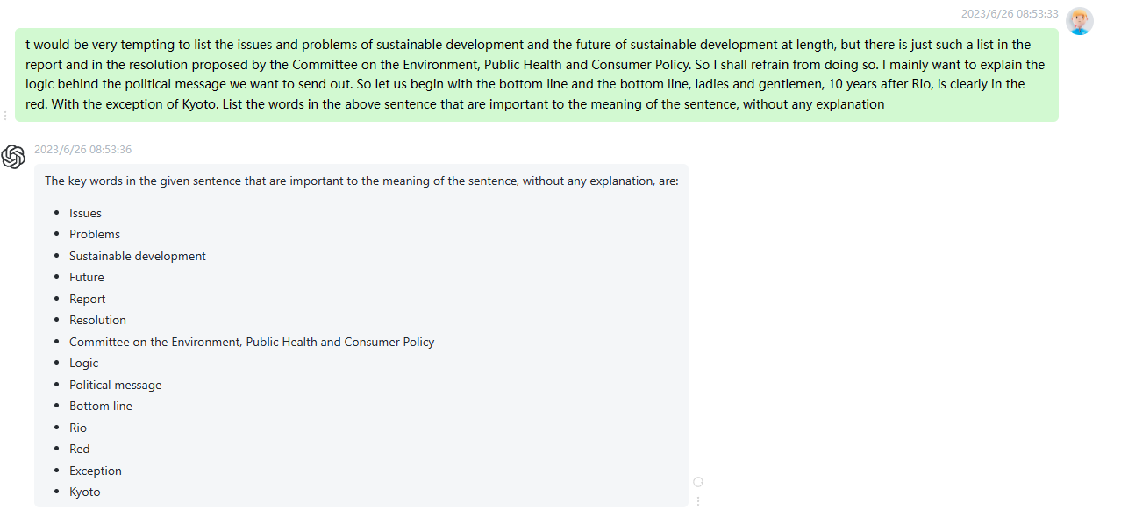

时延/帧：0.15s

2:

The report and the resolution contain numerous proposals on reducing poverty, on renewable sources of energy and on countless other points which all require resources, institutions, rules, proper local, national and global management, political management. It is this management that will, I think, be the main problem in the future. Reforming the international system of Bretton Woods institutions and of more recent institutions such as the World Trade Organization, for example when their rules clash with environmental protection. Reforms so that poor people can farm, agricultural reforms, for example, to give them water, energy, the rudiments needed to move to

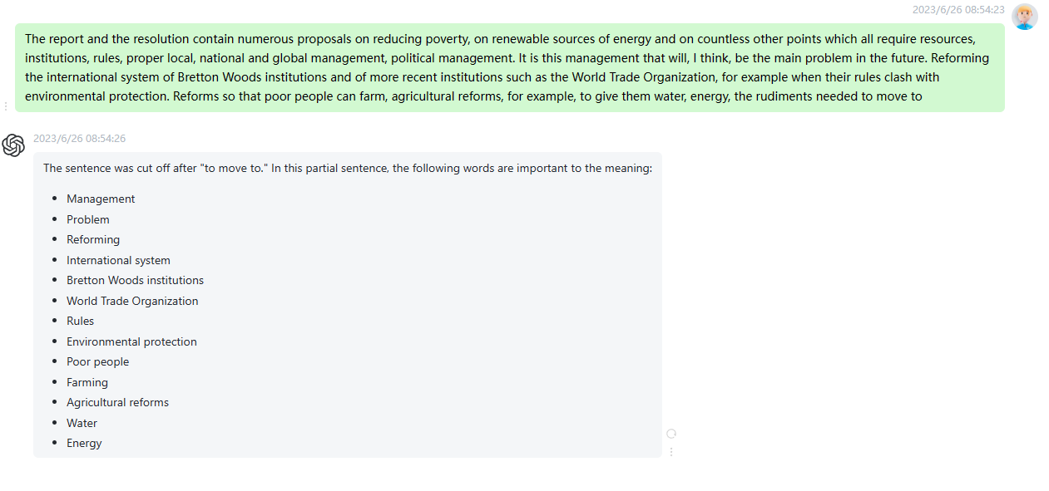

时延/帧：0.15s

3:

As we know, the United States are loath to make any kind of commitment. They are also distancing themselves from those who have. The role of the European Union is the sixty-four thousand dollar question. The European Union will be able to play a part for quite some time to come, but not for ever. And if it is going to play its part, it needs to put its own house in order. It needs to do more to promote environmental protection and social cohesion policies. To table commitments at international organisations in which it has enough clout to achieve

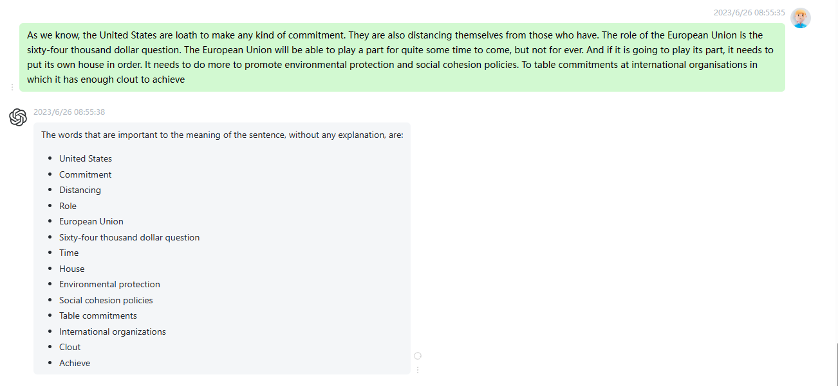

时延/帧：0.15s

4:

It was in Rio in 1992 that the international community established the concept of sustainable development. There is no doubt that in the intervening ten years the language used in speeches on the environment and development has changed, and changed for the better. Solemn undertakings have been made and conventions have been signed if not ratified, at least signed but we must also note, ten years on, that the situation on the environmental front has not improved, it has deteriorated, and that where poor and developing countries are concerned there has been no improvement there either. The inequalities have continued

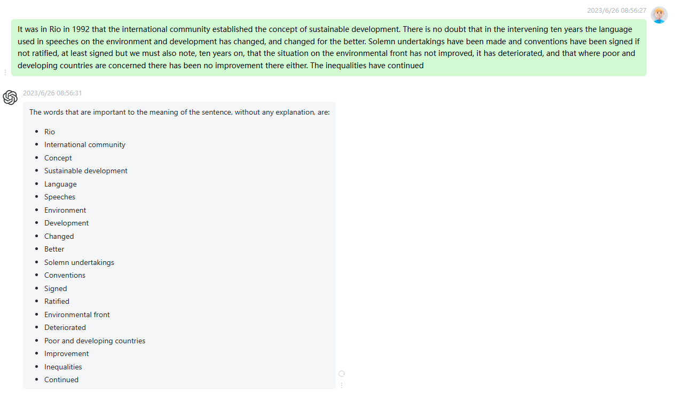

时延/帧：0.2s

5:

Johannesburg, which will take place in a few months, will not only be a time for taking stock; it will also be the moment of truth. It is not enough to have a ceremonial preaching of environmental values, which would be a repeat of what was said in Rio. Neither is it enough to have a chorus of lamentations: we need on the agenda a programme of ambitious political change for the next ten years. That, in any case, is the message which the Committee on Development and Cooperation has asked me to pass on to you. What we are

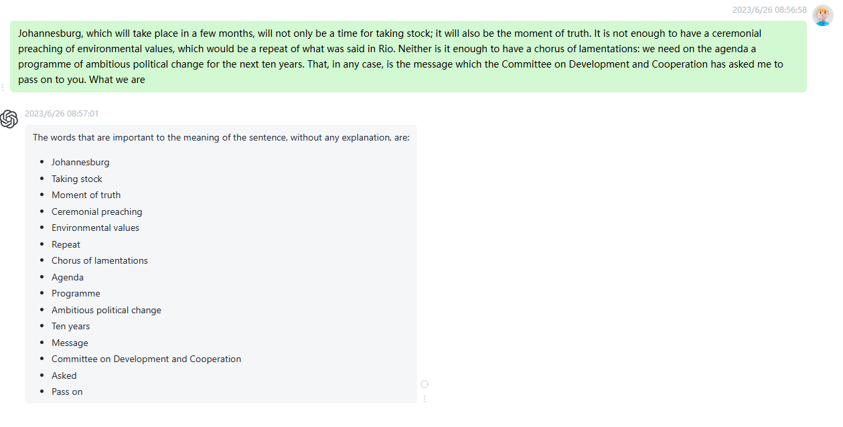

时延/帧：0.15s

6:

The fourth chapter is related to something the Commission said itself in the first document it published last year, that it was necessary to change production and consumption patterns. This is true, but it will require us to make some hard choices. I think, for example, that as far as we are concerned, some European Union policies and I am thinking in particular of the common agricultural policy, the fisheries policy and the trade policy will need to be reviewed if we are to avoid their running counter to the objectives of sustainable development. Furthermore, it will give us much

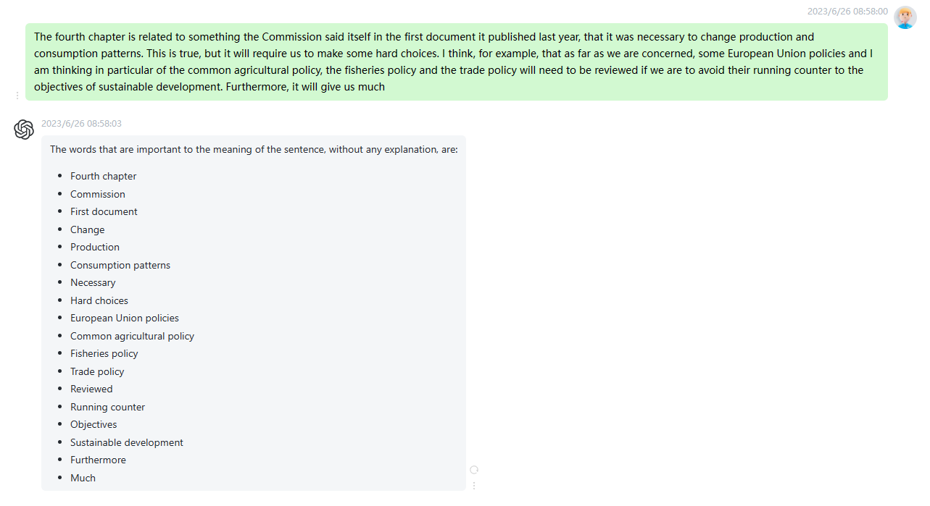

时延/帧：0.15s

7:

That, in essence, is the message which the Committee on Development wishes to see this House and the Commission, I turn here to Commissioner Nielson take away with them, because in a few weeks' time, there is a key date: the meeting in Bali, the last preparatory meeting before the Johannesburg Summit. So far, we have no cause for optimism because there is still no document on the table and up for discussion which shows real ambition. I therefore hope that our contribution will help the European institutions to play a leading role in this preparatory meeting, if there is

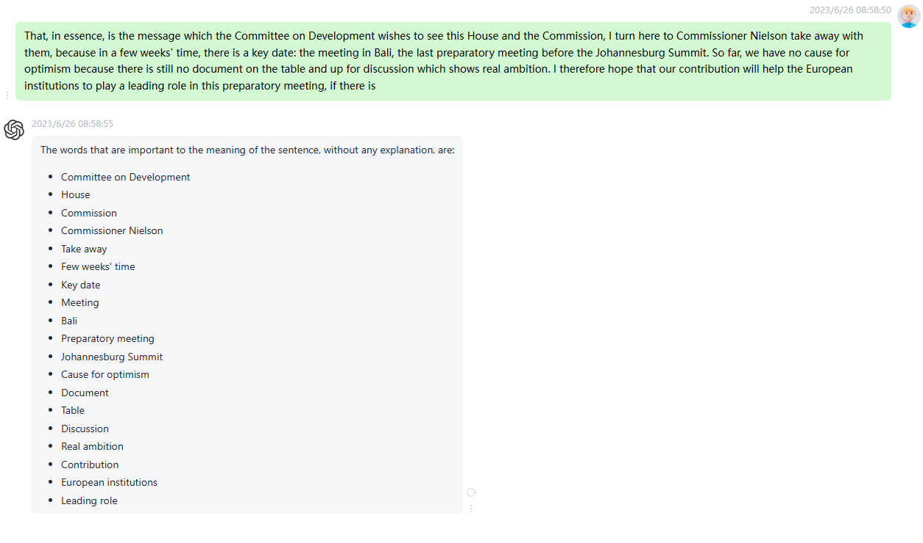

时延/帧：0.25s

8:

Mr President, on behalf of the committee, I should like to warmly welcome both reports and thank the rapporteurs for their excellent work. It is clear that the EU should be playing a leadership role in Johannesburg. Our own treaty commitments oblige us to do so, and European citizens expect us to do so. That means that the Council and the Commission must listen to Parliament's views and respond to them, because it is clear that Parliament wishes to see measures that are both ambitious and more targeted. The Development Council and the Seville Summit should therefore insist on a

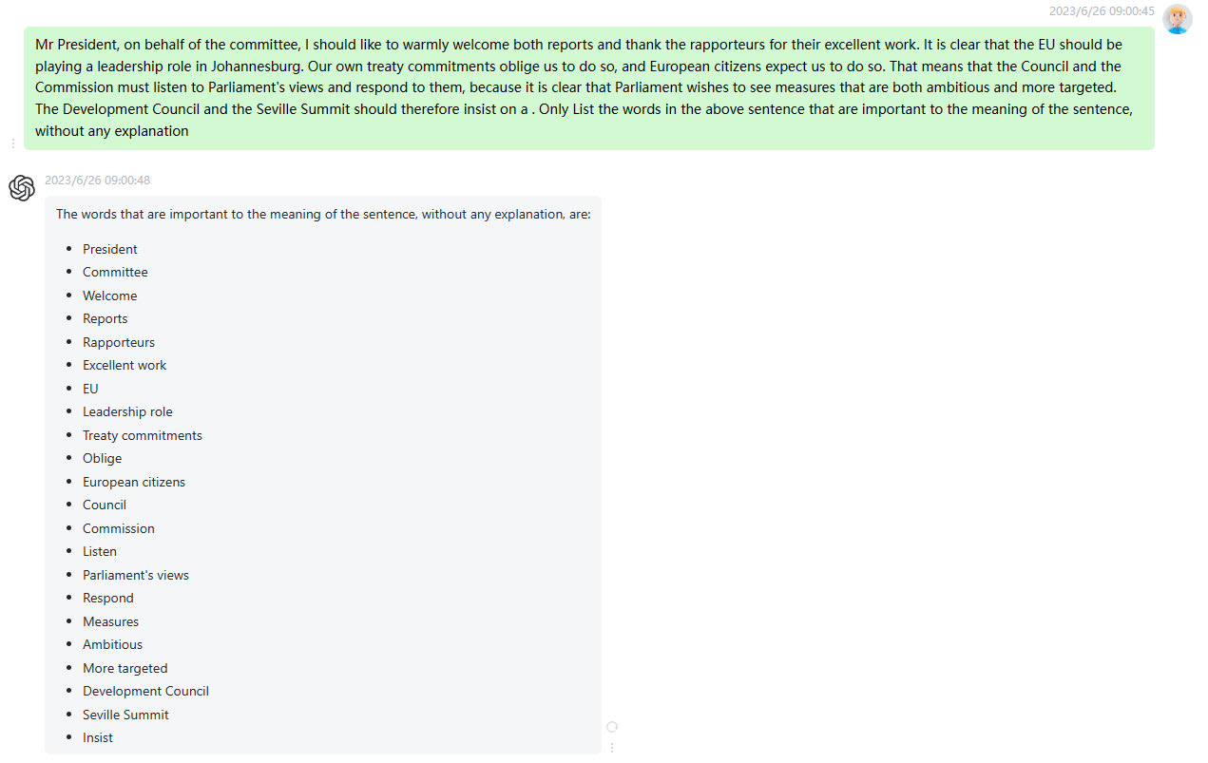

时延0.15s

9:

The Commission rightly identifies what it calls a global governance gap, with global market forces running far ahead of the ability of institutional mechanisms to contain them. And yet the measures which the Commission proposes to close that gap are woefully insufficient. In particular, the Commissions disproportionate emphasis on free trade and investment as engines for development should be balanced with far stronger commitments to binding frameworks for corporate accountability. As a first step we are proposing a directive on mandatory social and environmental performance. WTO rules must also be reformed to allow governments to make the vital distinctions that

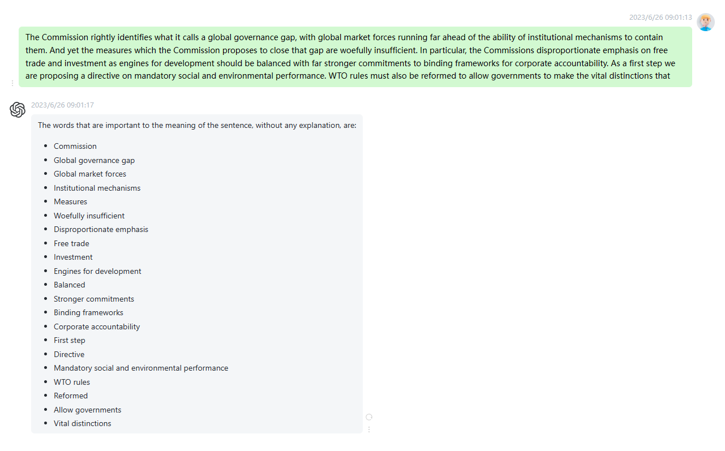

时延0.2s

10:

In any case, there is a further difficulty associated with the Rio de Janeiro Summit. This time, we shall be even more alone in the leadership of a global agreement. The political agenda that the European Union defines will, therefore, be critical for the success of the conference. I believe that both the Commission communication and the Papayannakis and Lannoye reports contribute to making this a good agenda. There are, however, certain paragraphs and a few amendments that, in our view, take away some of the objectivity and detachment of Parliament's resolution. I mean the Tobin tax and writing off

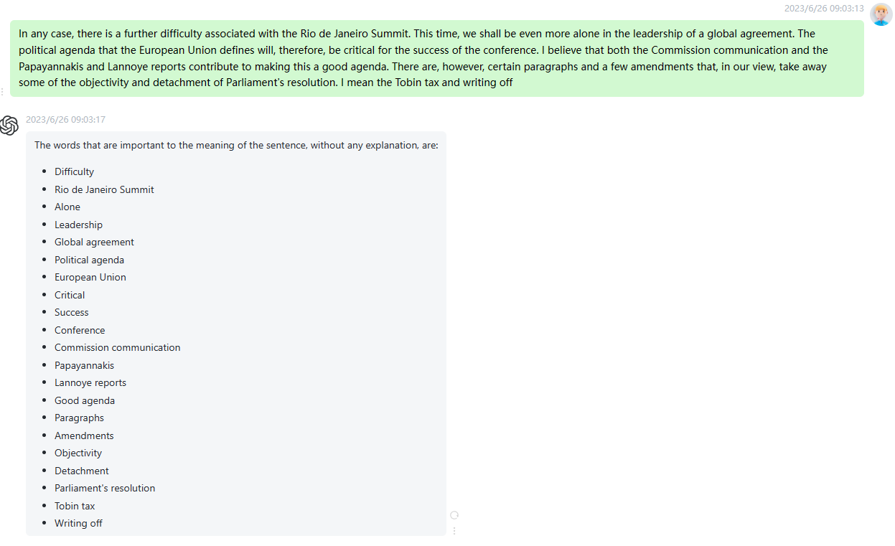

时延0.2s